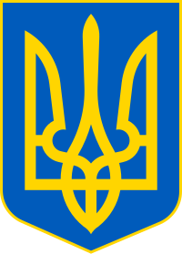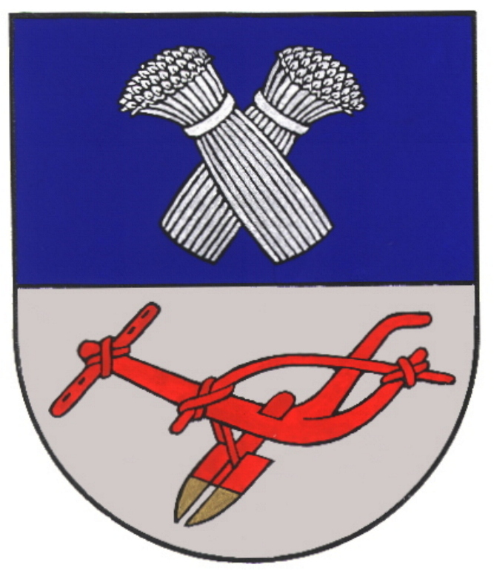

Cooperation Agreement
between Panevezys District Municipality (the Republic of Lithuania) and Municipality of Radechiv (Ukraine)

..... of July, 2023 No.

Panevezys District Municipality (the Republic of Lithuania) represented by the Mayor Antanas Pocius, of the one part, and Municipality of Radechiv (Ukraine) represented by the Mayor Stepan Petrovych Kokhanchuk, of the other part (hereinafter referred to as the „Parties“), guided by friendly relations, aiming to develop and strengthen mutually beneficial cooperation, and taking into account Protocol of Intentions (registration No. S1-80) between Panevezys District Municipality and Municipality of Radechiv, signed in 5th of April, 2023, concludes this Cooperation Agreement between Panevezys District Municipality and Municipality of Radechiv (hereinafter referred to as the „Agreement“).

ARTICLE 1. PURPOSE

- The Parties shall act in accordance with the principles of equality and mutual benefit of legal acts in force in Lithuania and Ukraine.
- The Parties shall develop mutual relations and initiatives, economic, social and cultural activities, implement joint projects, provide assistance in various areas as possible.

ARTICLE 2. AREAS OF COOPERATION

- The Parties shall agree as follows:
  - to cooperate in fields of education, science and technology, culture, sports, tourism, economy, rural and infrastructure development, nature protection, health and social assistance, training and skill development of employees and other areas important to both Parties;
  - to exchange good practices and information in local self-government activities;
  - to develop partnership relations between municipal educational, cultural, sports and art institutions and their collectives, youth groups, help them organize meetings and events, exchange delegations and share knowledge in their field;
  - to seek mutually beneficial cooperation between the Parties in business field;
  - to cooperate in the field of ecology, coordinate and fully support events aimed at environmental protection;
  - to organize preparation of joint projects and programs and to look for their financing opportunities from various sources of funds;
- This Agreement shall not limit cooperation in other areas – both Parties may cooperate on other issues and in other areas that are not mentioned in this Agreement, but may be useful for the residents of both municipalities.

ARTICLE 3. AGREEMENTS

- Detailed conditions of cooperation and their financing methods can be determined in separate agreements and contracts for the implementation of joint projects.
- This Agreement shall determine the development of joint programs and finding means to help achieve the goals of the Parties' cooperation.
- In order to summarize cooperation and define its development directions, representatives of each municipality shall meet for working visits when necessary.
- The Parties shall cover costs of hosting the official delegation in their municipality. Accommodation, meals and translation services shall be paid by inviting Party, arrival costs shall be paid by arriving Party, unless otherwise agreed.

ARTICLE 4. ENTRY INTO FORCE, AMENDMENTS AND TERMINATION OF THE AGREEMENT

- This Agreement is open-ended and shall enter into force on the date of its signing.
- Either Party may unilaterally refuse purposes of this Agreement. The Agreement may be terminated by one of the Parties in writing within three months from the date of receipt of the notice.
- Any amendment to this Agreement shall be the subject of a written agreement concluded by the Parties.
- This Agreement has been prepared in English in two originals, each having equal legal power, of which each Party has received one.

Panevezys District Municipality Municipality of Radechiv
The Republic of Lithuania Ukraine

Mayor of the municipality Mayor of the municipality

Antanas Pocius Stepan Petrovych Kokhanchuk

S. P. S. P.

Date Date

